**Task12-ChatGPT**

**Flexbox Layout Model**

The Flexbox layout model (Flexible Box Layout) is a CSS layout method designed to simplify the arrangement of items in a container, allowing for responsive design without the need for complex floats or positioning. Flexbox provides a more efficient way to distribute space and align items within a container, making it particularly useful for building responsive layouts.

**Key Flexbox Properties**

1. **flex-direction**: Defines the direction in which flex items are placed in the flex container.
   * Values: row, column, row-reverse, column-reverse.
   * Example: flex-direction: row; arranges items in a horizontal line.
2. **justify-content**: Aligns flex items along the main axis (horizontal or vertical depending on the flex-direction).
   * Values: flex-start, flex-end, center, space-between, space-around.
   * Example: justify-content: center; centers items along the main axis.
3. **align-items**: Aligns flex items along the cross axis (perpendicular to the main axis).
   * Values: flex-start, flex-end, center, baseline, stretch.
   * Example: align-items: stretch; makes all items stretch to fill the container.

**Example Responsive Layout Using Flexbox**

Here’s an example of a simple responsive layout using Flexbox:

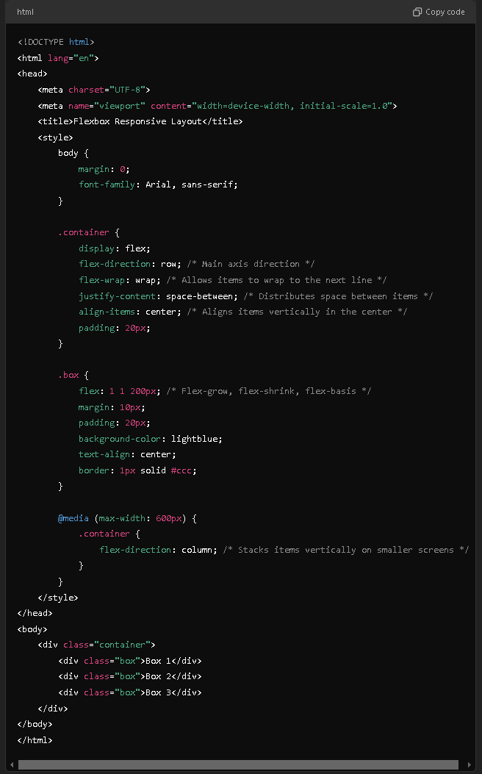

**Result :**

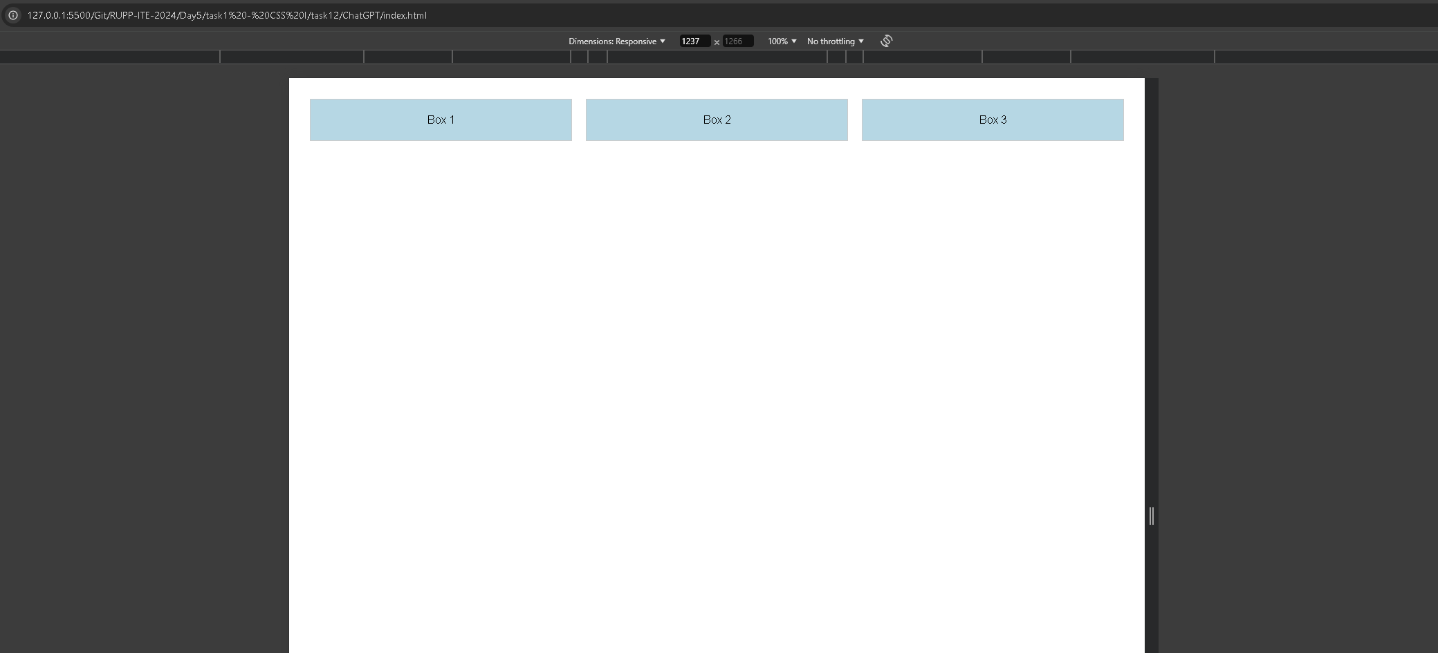

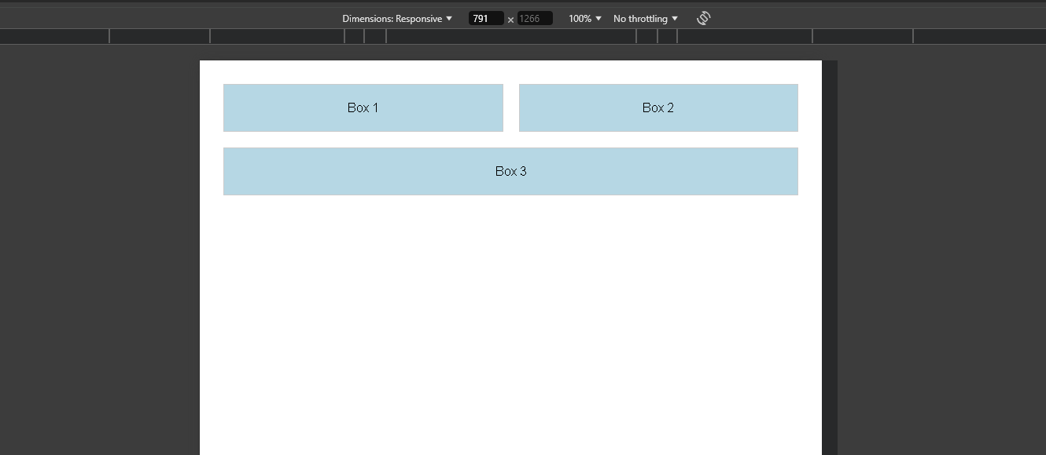

**Explanation of the Layout**

* **Container**:
  + **display: flex**;: Initiates Flexbox layout.
  + **flex-direction: row;:** Arranges items in a row.
  + **flex-wrap: wrap;:** Allows items to wrap onto the next line if there's not enough space.
  + **justify-content: space-between;:** Distributes space between items evenly.
  + **align-items: center;:** Vertically centers items in the container.
* **Box**:
  + **flex: 1 1 200px;:** Allows the box to grow and shrink, with a base width of 200px.
  + **margin: 10px;:** Adds spacing around each box.
  + **padding: 20px;:** Adds internal space within each box.

**Responsive Design**

The layout is responsive due to the use of Flexbox properties and the media query:

* When the screen width is less than 600px, the **flex-direction** changes to **column**, stacking the boxes vertically.

**Conclusion**

The Flexbox layout model simplifies responsive design by allowing elements to adjust their size and position dynamically. With properties like **justify-content, align-items,** and **flex-direction,** developers can create flexible and visually appealing layouts that adapt seamlessly to different screen sizes.